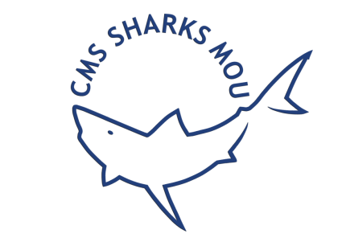
MEMORANDUM OF UNDERSTANDING
ON THE CONSERVATION OF
MIGRATORY SHARKS (Sharks MOU)

Benefits, Entitlements and Responsibilities of Signatories

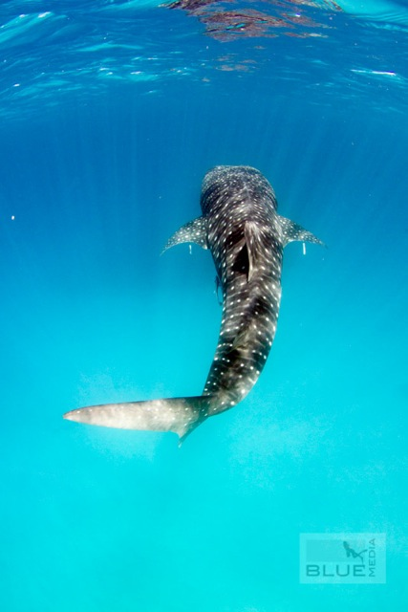

Table of Contents

Objectives of the Sharks MOU 3
38 sharks and rays covered 4
Signing procedure 5
Benefits of being a Signatory 6
Responsibilities of a Signatory 7
Annexes 8

- Form: Designation of authority to sign Memoranda of Understanding
- Form: Nomination of a Focal Point to the Memorandum of Understanding on the Conservation of Migratory Sharks (Sharks MOU)
Introduction


The Convention on the Conservation of Migratory Species of Wild Animals (CMS or the Bonn Convention) aims to conserve terrestrial, aquatic and avian migratory species throughout their range. It is an Intergovernmental Treaty, concluded under the auspices of the United Nations Environment Programme (UN Environment), which is concerned with the conservation of wildlife and habitats on a global scale. CMS acts as a framework Convention that encourages Range States to develop regional or global agreements covering single or groups of migratory species. The Memorandum of Understanding on the Conservation of Migratory Sharks (Sharks MOU) is one such global agreement. The MOU was concluded under the umbrella of CMS in Manila in 2010. The Secretariat of the Sharks MOU is located in Bonn, Germany.

Objectives of the Sharks MOU

The MOU is a legally non-binding international instrument that aims to restore a favourable conservation status for endangered shark species on a global level. It complements existing international wildlife conservation agreements, fisheries agreements and regional fisheries management organizations.
The Conservation Plan which was adopted by the Signatories in 2012 is based on five objectives:
- Increasing public awareness of threats to sharks;
- Improving the understanding of migratory shark populations through research;
- Ensuring that directed and non-directed fisheries for sharks are sustainable;
- Protecting critical habitats and migratory corridors; and
- Enhancing national, regional and international cooperation.
A favourable conservation status is achieved when the abundance and structure of populations of migratory sharks remain at levels adequate to maintain ecosystem integrity.
When undertaking activities to meet these objectives, Signatories should endeavour to cooperate through Regional Fisheries Management Organisations, the Food and Agriculture Organization, Regional Sea Conventions and biodiversity-related conventions. The Signatories should cooperatively strive to adopt, implement and enforce such legal, regulatory and administrative measures as appropriate to conserve and manage migratory sharks and their habitat.

38 Sharks and Rays Covered

There are currently thirty-seven shark species covered by Annex 1 of the Memorandum of Understanding:
ORECTOLOBIFORMES |  | RHINOPRISTIPHORMES
Rhincodontidae | Rhincodon typus | Rhinobatidae | Rhinobatos rhinobatos
LAMNIFORMES |  | Rhinidae | Rhynchobatus australiae
Lamnidae | Carcharodon carcharias |  | Rhynchobatus djiddensis
 | Isurus oxyrinchus |  | Rhynchobatus laevis
 | Isurus paucus | Pristidae | Anoxypristis cuspidata
 | Lamna nasus |  | Pristis clavata
Cetorhinidae | Cetorhinus maximus |  | Pristis pectinata
Alopiidae | Alopias superciliosus |  | Pristis zijsron
 | Alopias vulpinus |  | Pristis pristis
 | Alopias pelagicus | MYLIOBATIFORMES
CARCHARHINIFORMES |  | Mobulidae | Manta alfredi
Carcharhinidae | Carcharhinus falciformis |  | Manta birostris
 | Carcharhinus longimanus |  | Mobula mobular
 | Carcharhinus obscurus |  | Mobula japanica
Sphyrnidae | Sphyrna mokarran |  | Mobula thurstoni
 | Sphyrna lewini |  | Mobula tarapacana
 | Sphyrna zygaena |  | Mobula eregoodootenkee
Triakidae | Galeorhinus galeus |  | Mobula kuhlii
SQUALIFORMES |  |  | Mobula hypostoma
Squalidae | Squalus acanthias (northern hemisphere populations) |  | Mobula rochebrunei Mobula munkiana
SQUATINIFORMES
Squatinidea | Squatina squatina

Signing Procedure

This Memorandum of Understanding is open for signature by the Range States and regional economic integration organizations of the shark species listed in Annex 1.
There are currently 49 Signatories to the Sharks MOU:

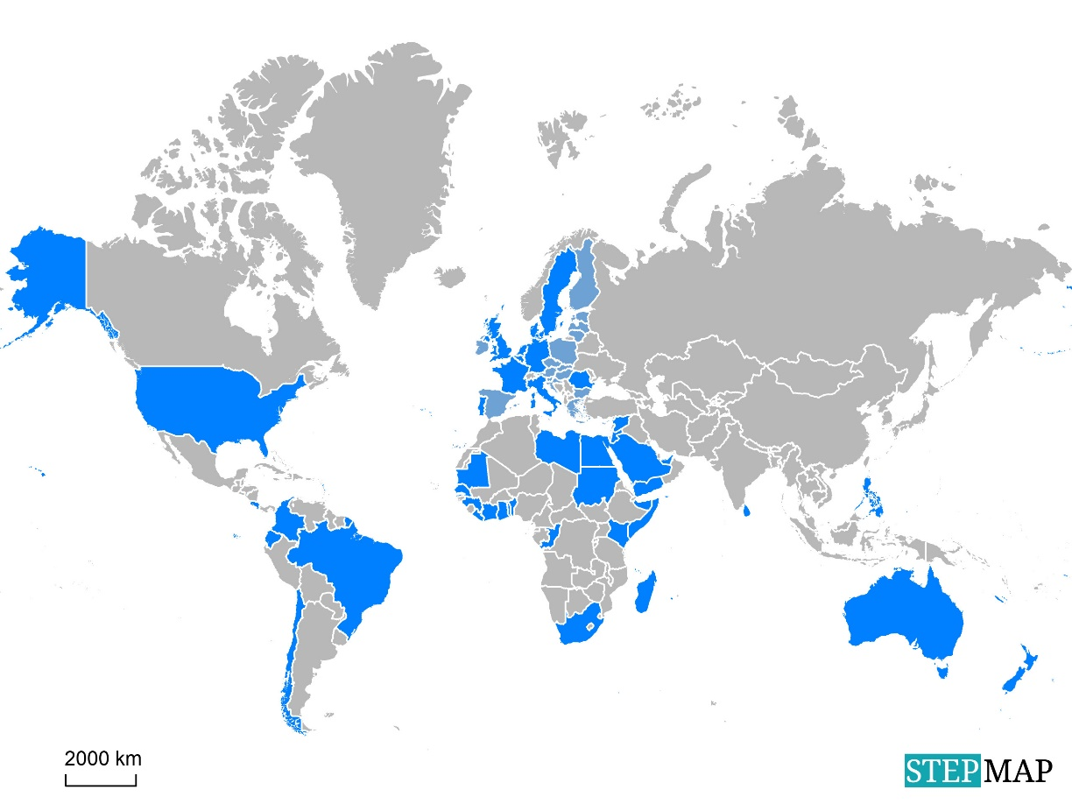

Range States are defined as any State that exercises jurisdiction over any part of the range of migratory sharks, or a State, flag vessels of which are engaged outside its national jurisdictional limits in taking, or which have the potential to take migratory sharks.

The Secretariat offers various options for States wishing to sign the Sharks MOU:
- Signature of the Memorandum by the Head of State, Head of Government, Minister for Foreign Affairs, or the responsible Minister or other high-level official with delegated authority. This may be arranged in the country concerned or in any other country on the occasion of a relevant meeting/workshop.
- Signature of the Memorandum at a Meeting of Signatories or other meetings organised by the Secretariat, by a duly accredited Official – subject to presentation of a suitable original Instrument of Authority , prior to the meeting.
The Memorandum of Understanding shall take effect for a new Signatory on the first day of the month following the date of signature.

Benefits of being a Signatory

Signatories to the Sharks MOU can benefit in many ways:
- Access to support in developing national or regional conservation strategies for sharks (taking account of the need for collaborative trans-boundary measures);
- Invitations to attend and participate in Meetings of the Signatories and, as a consequence, being in the position to shape future policies and implementation of the Sharks MOU;
- Access to support in developing partnerships or collaborative shark conservation activities with other Range States, Inter-Governmental (IGOs) or Non-Governmental Organizations (NGOs);
- Invitations to participate in occasional Capacity-Building or Technical Workshops, including potential access to funding to support attendance at these gatherings;
- Access to technical advice and support from the Advisory Committee for the Sharks MOU;
- Access to funding opportunities for shark conservation initiatives (e.g. through the UNEP/CMS Small Grants Programme or in partnership with other Range States or Co-operating Partners);
- Enhancement of the Signatory's international visibility in the field of shark conservation through cooperating with other Signatories in global and regional shark conservation efforts;
- Access to a range of international networks, specialists, IGOs and NGOs.
It is also worthwhile highlighting that any effective measures introduced to conserve migratory Sharks are likely to deliver much wider benefits to the conservation of other marine species.

Responsibilities of a Signatory

New Signatories should designate a Focal Point who will be in charge of the communication among Signatories and for the coordination of implementation measures and activities under the MOU.
Signatories should strive to adopt, implement and enforce such legal, regulatory and administrative measures as may be appropriate to conserve migratory sharks and their habitats, in a spirit of consensus, cooperation and mutual support, and to the extent that resources permit.
Signatories should endeavor to coordinate their efforts; to cooperate in emergency situations requiring concerted international action; to take appropriate measures for the recovery of shark populations; to exchange information, and to cooperate with a view to assisting each other to implement the Sharks MOU, particularly in the areas of research and monitoring.
Signatories should report on the implementation of the MOU at each Meeting of the Signatories.
Financial contributions to the MOU are voluntary, which gives Signatories the flexibility to make a voluntary contribution when they have the capacity to do so. Voluntary financial and/or in-kind contributions, however, are important for the on-going operations of the Sharks MOU as the only source of funding.

Annexes

AUTHORITY TO SIGN MEMORANDA OF UNDERSTANDING

I, [full name and title of the Head of State, Head of Government, Minister for Foreign Affairs, Minister of Environment or other responsible Minister],

HEREBY AUTHORIZE [full name and title of representative] to sign the [name of the Memorandum of Understanding] on behalf of the Government of [name of State].

Done at [place] on [date].

[Signature]

Designated Authority and Focal Point Form for the Memorandum of Understanding on the Conservation of Migratory Sharks

Recalling Paragraph 15a of Section 5 of the above MOU:

“Each Signatory should designate a focal point for communication among Signatories and for coordinating implementation measures and activities under this Memorandum of Understanding and the Conservation Plan, and communicate the complete contact details of this authority, and any subsequent changes thereto, to the Convention Secretariat.”

I hereby designate the following governmental institution as the authority to serve as focal point for the MoU and for implementing activities under the MoU:

Ministry/Department/Organisation:

I hereby nominate the following person as focal point for purposes of communicating with the Secretariat and other Signatories:

Family name: (Mr./Ms./Dr.)………………………… First name:

Title/Function:

Department:

Organisation:

Address:

Tel.:

Fax:

E-mail:

Signature: Date: ……………………… Seal/Stamp of Ministry

(Responsible Minister)

Please return to the Secretariat by email to cms.secretariat@cms.int

Kindly contact the Secretariat of the UNEP/CMS Sharks MOU in Bonn by telephone or e-mail to make the necessary arrangements, or if you have any questions. Thank you.

Signatories to the MOU can propose further species to be listed in Annex 1 of the MOU.
See Annexes for Model of Instrument of Authority
This instrument should also be printed on the letterhead of the relevant Minister to unambiguously indicate that the person signing the instrument has authority to do so. However, neither letterhead not an official seal may replace the signature of one of the relevant authorities authorized to sign this instrument.

